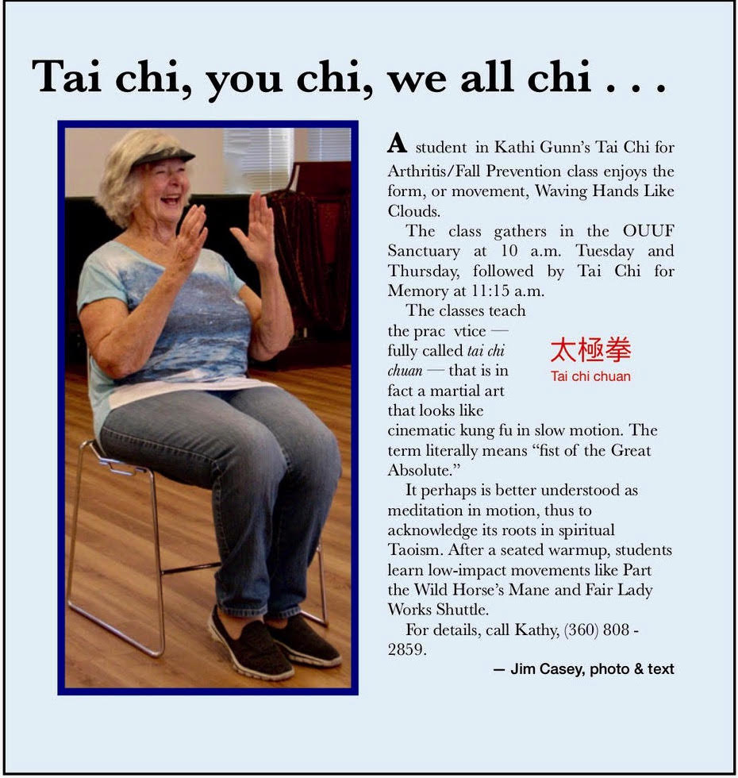
Thursday, December 6
Tai Chi for Arthritis/Fall Prevention, 10:00am
Contact: Kathi Gunn,
(360) 808 - 2859

Tai Chi for Memory, 11:15am
Contact: Kathi Gunn,
(360) 808 - 2859

Sunday, December 9
Annual Congregational Meeting, 12noon

Monday, December 10
Dance Exercise for Parkinson’s Disease, 10:30am
Contact: Marsha Melnick,
(360) 683 - 5712

RE Committee Meeting, 11:00am
Congregants Home

Tuesday, December 11
Tai Chi for Arthritis/Fall Prevention, 10:00am
Contact: Kathi Gunn,
(360) 808 - 2859

Second Tuesday Brunch,
11:00 am – Mariner Restaurant
Contact: Vivian Mulligan vivian.mulligan@gmail.com

Tai Chi for Memory, 11:15am
Contact: Kathi Gunn,
(360) 808 - 2859

CANCELLED: Ted Talk TUUesday, 1:00 pm
Volunteer Hosts Needed!
Contact: Vivian Mulligan vivian.mulligan@gmail.com

Choir Practice, 3:00 - 4:30 pm
Contact: Joel Yelland at joelyelland@gmail.com

Wednesday, December 12
Dance Exercise for Parkinson’s Disease, 10:30am
Contact: Marsha Melnick,
(360) 683 - 5712

All Things Considered, Women's Evening Group, 7: 00pm, Member's Home
Contact: Jean Stratton
(360) 452-6719

Men's Evening Group, 7:00pm, Member's Home
Contact: George Stratton (360) 452-6719

Thursday, December 13
Tai Chi for Arthritis/Fall Prevention, 10:00am
Contact: Kathi Gunn,
(360) 808 - 2859

Tai Chi for Memory, 11:15am
Contact: Kathi Gunn,
(360) 808 - 2859

Reflections, Women’s Group 1:00 P.M. (scent free)
Contact: Serena Mylchreest at serena@mylchreest.com

Saturday, December 15
Holiday Craft Event, 12noon
Contact: Jolie Will: jolieandgeorge@gmail.com

Sunday, December 16
Potluck, 11:45am, please include written ingredient information with your dish.
Board of Trustees Meeting, 12:30pm

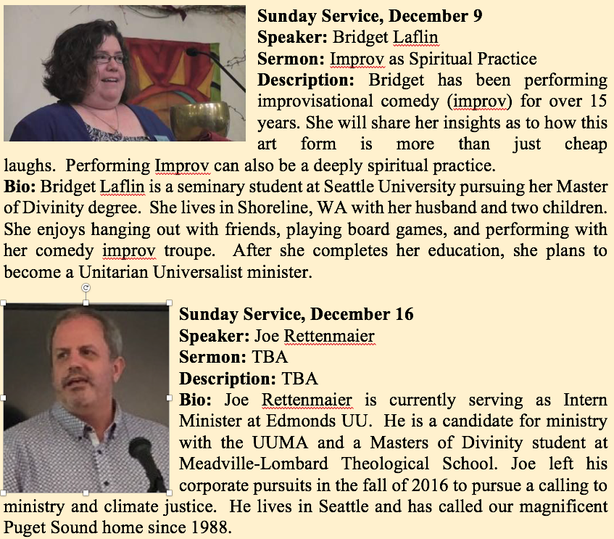

OUUF Weekly Update
An Inclusive Community
Calendar
Dec 6 - 16
NovOc 21OctoberOct
Oct 4 - 14
Upcoming December Services
December 6, 2018

1033 N. Barr Road
P O Box 576
Carlsborg, WA 98324

360-417-2665
info@olympicuuf.com

ANNOUNCEMENTS
OUUF BOARD OF TRUSTEES

President:
Dianne Whitaker
President@OlympicUUF.com
Vice President:
Elaine Webber
Secretary:
Dave Large
Treasurer:
Sylvia Watkins-Castillo
Treasurer@OlympicUUF.com

Trustees-at-Large:
Susan Kowitz
Rose Prestipino
Greg Sensiba
Nick Dante

OUUF STAFF

Elinor Tennyson
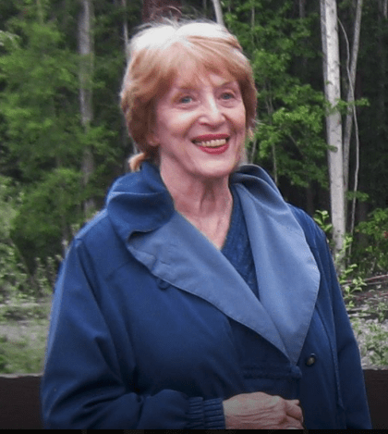
Administrative Coordinator
Admin@OlympicUUF.com

Pattie Miles
Social Media Editor
socialmedia@OlympicUUF.com
Newsletter Creation & Distribution
Newsletter@OlympicUUF.com

Children's Religious Education Staff
Childrensdre@OlympicUUF.com
Cynthia Green
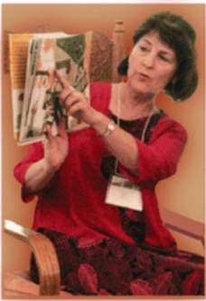
Sandy Goodwick
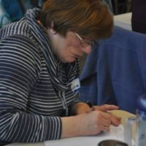
Julia Buggy
Childrensdre@OlympicUUF.com
James Casey
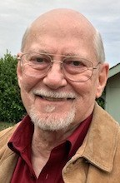
Membership Coordinator
Membership@OlympicUUF.com
Jack Webber
Webmaster
webmaster@OlympicUUF.com

Send announcements in Word or in the body of the email and photos in jpg. No PDFs, please. If you would like your congregational event or meeting announced in the Weekly, Order of Service, or listed on the OUUF website calendar, please send the details to Social Media Editor, Pattie Miles at socialmedia@OlympicUUF.com.

The OUUF annual congregational meeting will be held Sunday, December 9th, after the service. If you are a member in good standing, please complete a ballot either at the service or by mail if you cannot attend.
The Unitarian Universalist Association (UUA) is requesting congregation participation in a poll of whether to place a Statement of Conscience (SOC) on the Final Agenda at General Assembly 2019. The SOC is attached for your review and there will be an opportunity to discuss it at our Annual Congregational Meeting December Is on the OUUF website. Search “Social Conscience.” 9th. https://olympicuuf.com/wp-content/uploads/2018/12/SOC-UUA.pdf
CHRISTMAS POTLUCK. Once again, your Christmas can be brightened by coming to our Christmas potluck on Dec. 25 (when else?). I think we will eat about 1:00 so we have time to do our White Elephant gift exchange. Let me explain the term. Long ago in India, white elephants were considered sacred. They could not be used for any labor and were to be given only the best food. Maharajas would give white elephant as gifts because they were useless and ate too much. Thus, a white elephant is something useless that you already have, and you want someone else to provide room for. Look around your house and find that White Elephant just sitting, waiting for a new home. Sign-up sheets will be at OUUF on Sunday. See you on Christmas! Contact: Dana Casey, raven225@olypen.com

As part of our winter celebration this year, UUSC is collecting cards, drawings, and welcome messages to send to our partners on the U.S.-Mexico border who are working tirelessly to support asylum-seekers as they arrive in the United States. These cards will be shared with migrant children and families who have recently arrived to remind them that they have a home and are welcome here.The children and young at heart are invited to make welcome messages - please remember to bring your completed message/card back to the fellowship and place in the basket by name tags next Sunday, December 9. Contact: Sandy Goodwick, sgoodwick@aol.com
Link: https://www.uusc.org/initiatives/share-a-message-of-welcome-and-joy/

Grace Yelland and Jolie Will are hosting a holiday craft event on December 15th, at OUUF, from 12noon-4pm. It is open to all ages and we will be making reusable gift bags and a simple decoration. Supplies will be provided. RSVP PLEASE!! to Jolie Will: jolieandgeorge@gmail.com OR sign up at OUUF Sunday Service so that we will have enough supplies.

December for our UU Children. What does ‘December’ look like, feel like… to UU children? What do we ‘include’? How can our children celebrate the magic of being a child while cherishing the history and spirit of our principles and sources? Well, this is what we are planning for the month of December. Anyone who’s worked with children during the month of December knows this is a magical, exciting time. Come join us every Sunday in December – hear our stories and be part of our activities! December 2 – marks the beginning of both Hanukkah and Advent. Winter solstice is just weeks away. Kwanzaa comes at the end of the month. So where do we fit all of this in, along with Santa and Christmas trees and … During ‘Story for All Ages”, we will touch briefly on all these eventsAnd our children will create some fun ways to honor a few of these special holidays. So, come and make/take home a OUUF AdventUURE kit! Questions? Want to help our OUUF kids? Please contact Sandy Goodwick (sgoodwick@aol.com). Go to this link for complete details: RE December Activities
Gentle reminder all you OUUF angels and elves: All unwrapped gifts for children in foster care need to be returned to the church in a bag with the tag attached by December 9th. Great job everyone. Thank you for your incredible generosity!! Florence Bucierka
At popular request, we will be holding the Peninsula Community Drum Circle 1 week early this month, on December 18, 2018, from 6:30-8:30 PM. As usual, we will gather at the OUUF hall. Everyone is invited, regardless of age or experience (new to drumming or seasoned drummers). Come on over and drum with us in the joyous spirit of the season! We'll provide the drums & rattles! Contact: Penny Burdick, mailto:mandalaht@gmail.com

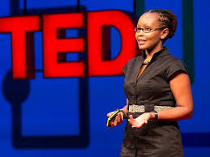
Next Two Ted Talk tUUesdays CANCELLED Unless We Get a New Volunteer. We are looking for someone to lead Ted Talk tUUesday on 12/11/2018 and 01/ 08/2019. Besides choosing topics, this would include hooking a computer (yours or the church’s) up to our Smart Screen. The videos you use could be downloaded from ted.com or accessed from a direct link to YouTube.com. You don’t need to worry about coffee and snacks because, thanks to Dave Large and Dianne Whitaker, that is taken care of. Please contact me at vivian.mulligan@gmail.com if you would like to volunteer. Otherwise, December and January are cancelled because the old gray mare ain’t what she used to be. I may start up again in February. Full details: https://olympicuuf.com/wp-content/uploads/2018/07/December-2018-TED-TALK-UPDATE.pdf
The OUUF Social Action Taskforce encourages OUUF to continue to support the efforts of the Interfaith Community in combating hate and ignorance that turn people against each other. You will find current social justice news submitted by Sandy Goodwick at this Social Justice link on the OUUF website: Interfaith News

Stephanie Neal, Milton Patrie’s daughter, is now living in Sequim and helping Milton with his day to day activities. She has asked that I let you know that Milton is enjoying his music and visits with friends. He especially enjoys having people come by for a visit or a short excursion. This also gives Stephanie a much-appreciated chance to run errands or meet a friend for coffee. If you would like to visit with Milton, please drop Stephanie a text message to make sure Milton will be home! Stephanie Neal: text at 541 292-9390
*****************************************************************************

IN OUR COMMUNITY
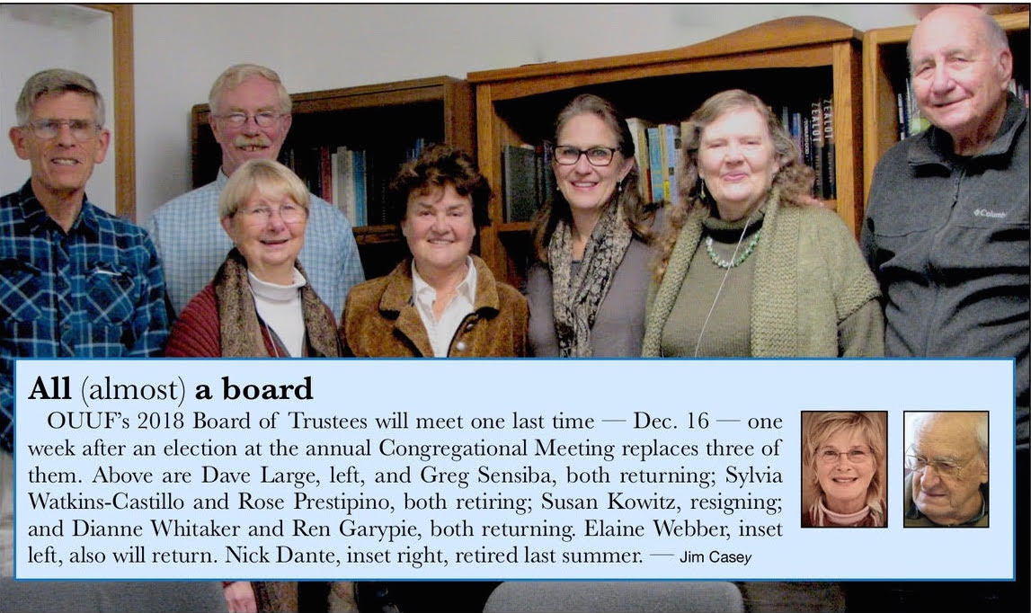

Save the dates for Winter Peace Choir - Tentative performance date is in late March. Contact: Interfaith, interfaithclallamcounty@gmail.com.

ONGOING GROUPS

Reading for the fun of it!
Short Story Book Group
First & Third Tuesdays at 10 am
To learn more contact:
Kitty Hawks
206-755-2832 or
alettehawks@yahoo.com

Tuesday Brunch
Second and Fourth Tuesdays
11 am at the Mariner Restaurant in the JCPenney mall in Sequim
For more information contact:
Vivian Mulligan
vivian.mulligan@gmail.com

Ted Talk tUUesday
Second Tuesday at 1:00 PM
At OUU Fellowship Hall
For more information contact:
Vivian Mulligan
vivian.mulligan@gmail.com

Breakfast Men's Group
First & third Wednesdays
8 AM at OUU Fellowship Hall
Participants bring food to prepare. Congenial conversation and support.
For More information contact:
Bob Nuffer
e_nuff@msn.com

OUUF Men’s Group
Wednesdays, 7-9 pm
At members’ homes.
For More information contact:
George Stratton
(360) 452-6719

OUUF Women’s Groups
All Things Considered
Evening Group
Wednesdays, 7-9 PM. At members’ homes
For More information contact:
Jean Stratton
360-452-6719 or
jeanmstratton@gmail.com

Reflections
Second and fourth Thursday 1-3 PM at the Fellowship Hall
For More information contact:
Serena Mylchreest
serena@mylchreest.com

Choir
OUUF Sundays at 9:30 am and Tuesdays at 3:00 pm.
Newcomers welcome!
For More information contact:
Choir Director
Joel Yelland
509-322-5328 or
JoelYelland@gmail.com

For details on how to join or start an OUUF Affinity Group:
OUUF Affinity Groups

