Sunday, August 25
Please join us for coffee and snacks after the service.

Monday, August 26
Dance Exercise for Parkinson’s Disease, 10:30am
Contact: Marsha Melnick, (360) 683 - 5712

Tuesday, August 27
Fourth Tuesday Brunch, 11:00pm
Location: Mariner Café, Penney’s Shopping Center, Sequim
Contact: Rose, roseprestipino@gmail.com

Community Drum Circle, 6:30pm
Contact: Penny Burdick at DrPennySequim@gmail.com
or (360) 683-3819

People for MAT Group, 7:00pm
Contact: Clare Hatle, hatlerclare444@gmail.com
or (360) 582-6451

Wednesday, August 28
Dance Exercise for Parkinson’s Disease, 10:15am
Contact: Marsha Melnick, (360) 683 - 5712

All Things Considered, Women's Evening Group, 7: 00pm, Member's Home
Contact: Jean Stratton (360) 452-6719, jeanmstratton@gmail.com

Men's Evening Group, 7:00pm, Member's Home
Contact: George Stratton (360) 452-6719

Sunday, September 1
Sunday Services Committee
11:45am, Library
Contact: Bob Nuffer, e_nuff@msn.com

1033 N. Barr Road
P O Box 576
Carlsborg, WA 98324

360-417-2665
info@olympicuuf.com

Calendar
August 22 – September 1
NovOc 21OctoberOct
Oct 4 - 14
Upcoming Sunday Service
August 22, 2019

OUUF Weekly Update
An Inclusive Community

ANNOUNCEMENTS
OUUF BOARD OF TRUSTEES

President:
Dianne Whitaker
President@OlympicUUF.com
Vice President:
Elaine Webber
Secretary:
Dave Large
Treasurer:
Kitty Hawks
Treasurer@OlympicUUF.com

Trustees-at-Large:
Ren Garypie
Pat MacRobbie
Don Hatler
Greg Sensiba

OUUF STAFF

Elinor Tennyson
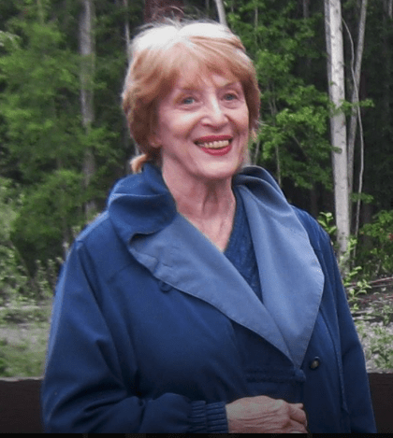
Administrative Coordinator
Admin@OlympicUUF.com

Pattie Miles
Social Media Editor
socialmedia@OlympicUUF.com

Children's Religious Education Staff
Childrensdre@OlympicUUF.com

Julia Buggy
Childrensdre@OlympicUUF.com

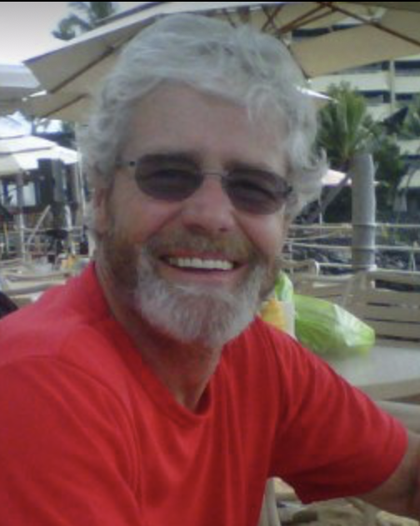
Jack Webber
Webmaster
webmaster@OlympicUUF.com

Pastoral Care Lead: George Will
pastoralcare@olympicuuf.com

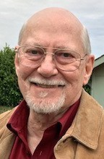
The celebration of Jim Casey's life will be held September 22nd at 1:30 in the Fellowship sanctuary and memories of Jim may be shared at this time. Bringing a light snack for sharing at the service will be appreciated. Dana prefers contact by email at raven225@olypen.com rather than phone calls.

7@7 DINNERS are informal potlucks which provide a wonderful opportunity for OUUF members and friends to get to know each other. They don't have to include exactly 7 people at 7 o'clock-- some are held at lunch or brunch time. You may sign up to be a host or not. We're starting the September/October round of 7@7 dinners. If you wish to participate contact Serena Mylchreest at coffee hour or email her at serena@mylchreest.com

Nominating Committee Seeking Candidates
The OUUF nominating committee is putting together a slate for our December annual meeting to elect our Board of Trustees, an endowment committee director and the nomination committee for 2021.

Recently, members were emailed the proposed bylaw changes. The committee is seeking candidates based on the proposed changes to the bylaws and assuming the congregation will pass the bylaws at the September 29, 2019, Congregational meeting. The proposed Board of Trustees will consist of a President, Vice-president, Director of Finance and four at-large members.

Please speak to any of the committee members if you are interested in one of these positions or you wish to make suggestions to the committee. The nominating committee members are Catharine Covert, Penny Burdick, George Stratton, Susan Harris, and Kathi Gunn. Catharine Covert, covert@olympus.net

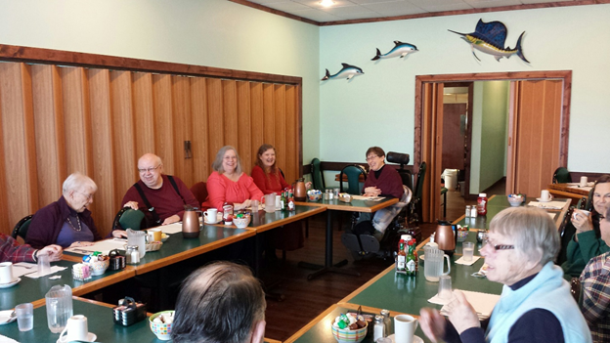
Tuesday Brunch
The second Brunch in August will be held August 27th in Sequim at the Mariners Restaurant. We come together at 11:00 AM to have breakfast or lunch and to visit with each other. Sometimes we laugh and tell jokes and sometimes we have serious discussions. It all depends on the mood of the crowd Come and participate and if you wish, bring a story to tell. Rose, roseprestipino@gmail.com
Herding Cats Event / Confrontation with Mountains! August 29, 11ish o'clock. Hurricane Ridge (first picnic area beyond visitor center at the top). Get in touch with your nature at the most spectacular picnic spot in the world.! 9:30 am form carpools at our Fellowship. 10 am: form carpools at the visitor center before entering the park. Bring your park pass. Bring camp chairs. Bring food to share. Bring whatever! Contact: Kitty, alettehawks@yahoo.com
Going for the Trash! Highway Cleanup. August 31. 9:30 am. Meet on River Road / South Side (just beyond 101 exits & entrances). Pick up trash! Might find some money...dead animals...run over cell phones... disgusting stuff. Only the brave participates! And that is YOU!
Contact: Trash Maven Kitty, alettehawks@yahoo.com

End of Summer/ Back to School Tie Dye Extravaganza Will Be on Sept 8. Adults and kids alike are invited for fun dying and organic popsicles. Julia Buggy, our DRE, is headed to a Unitarian Universalist family camp, with Amara age 7 and Rayna age 5. Elliot Creative Arts is 5 days. She will be learning some new fabric dying techniques such as low water immersion that she hopes to share with us! Thanks for the generous donations, we now have plenty of extra shirts set aside for those who don't bring their own. If you plan on coming feel free to bring kitchen gloves and a piece of light colored, preferably cotton fabric. Get creative, underwear, socks, handkerchiefs welcome.
OUUF ACTIVITES AND PHOTOS
We would like to add pictures and/or videos to our website and Facebook page of OUUF activities and people. If you have a copy to share, please send to either Jack Webber at webmaster@ouuf.com or Elinor Tennyson at admin@olympicuuf.com

PORT ANGELES RIDESHARE
We have several persons who would love to be able to attend OUUF Sunday services but need a ride from Port Angeles. If you would be able to help please contact Elinor Tennyson at admin@olympicuuf.com or call 360-417-2665.

VOLUNTEERS. We have the most incredible volunteers and many contributed time, materials and labor to make our library more welcoming and inviting. A special thank you goes to the Havens family for painting, Susan Harris and Lou Foldoe for donating furniture and rug, Elaine and Jack Webber for donating plants, Dianne and Daniel Whitaker for donating a poster, and Phil Zenner who donated frames, mats and labor for the wall pictures. We cannot forget to thank Geri Napier, our awesome librarian. We are a small community and it takes people such as these to make OUUF a place of love and warmth. Thank you and appreciation from all of us, Elinor

CONTEMPLATIVE SERVICE: There will be no Contemplative Service in August. The next service will be held on Tuesday, Sept. 3rd at 6:00 pm. For information contact Joel Yelland> JoelYelland@gmail.com or Diane Hill-Dwyer > DJZHill@Q.com

Volunteers are needed to go through containers of event decorations that are in the sanctuary closet. Decisions need to be made about what to keep and what should be eliminated. This process will be an opportunity to review what is available for future events. Please contact Elinor Tennyson at admin@olympicuuf.com or call 360-417-2665.

Message from your Sunday Service Committee
A good preacher or teacher or presenter or whatever you want to call the person who delivers the message on Sundays needs to comfort, inspire or challenge us. Sometimes they do all three. Your SSC has recruited some exciting speakers for the Fall and Winter. First, the retired pastor of Quimper UU, Rev. Bruce Bode, has agreed to speak to us twice in September and once in November. Bruce is a powerful speaker and we believe you will enjoy him. Come, check him out. One of our long-time favorites, Rev. Amanda Aikman has agreed to speak twice in November. Joseph Bednarik has agreed to two messages in December. Joe Rettenmaier who always speaks from his heart is returning in October. Margo Reinhart has a special message from the Bhagavad Gita planned for December. It is also our great good fortune to have Brother Jamal Rahman returning to speak to us on January 26, 2020. Come here all our great speakers. You will be inspired, challenged, and comforted.
Bob Nuffer, e_nuff@msn.com.

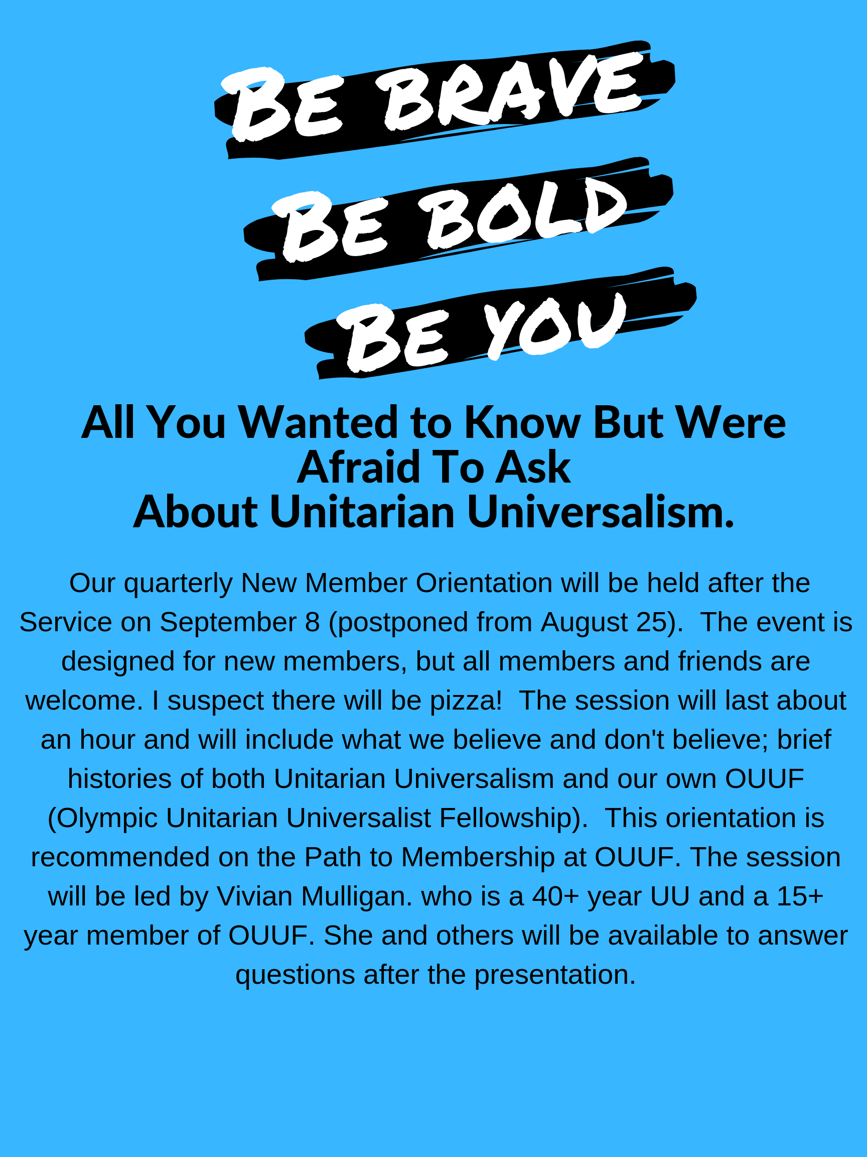
ONGOING GROUPS

Reading for the fun of it!
Short Story Book Group
First & Third Tuesdays at 10 am
To learn more contact:
Kitty Hawks
206-755-2832 or
alettehawks@yahoo.com

Tuesday Brunch
Second and Fourth Tuesdays
11 am at the Mariner Restaurant in the JCPenney mall in Sequim
For more information contact:
Rose Prestipino, roseprestipino@gmail.com

OUUF Men’s Group
Wednesdays, 7-9 pm
At members’ homes.
For More information contact:
George Stratton
(360) 452-6719

OUUF Women’s Groups
All Things Considered
Evening Group
Wednesdays, 7-9 PM. At members’ homes
For More information contact:
Jean Stratton
360-452-6719 or
jeanmstratton@gmail.com

Choir
OUUF Sundays at 9:30 am and Tuesdays at 3:00 pm.
Newcomers welcome!
For More information contact:
Choir Director
Joel Yelland
509-322-5328 or
JoelYelland@gmail.com

For details on how to join or start an OUUF Affinity Group:
OUUF Affinity Groups

