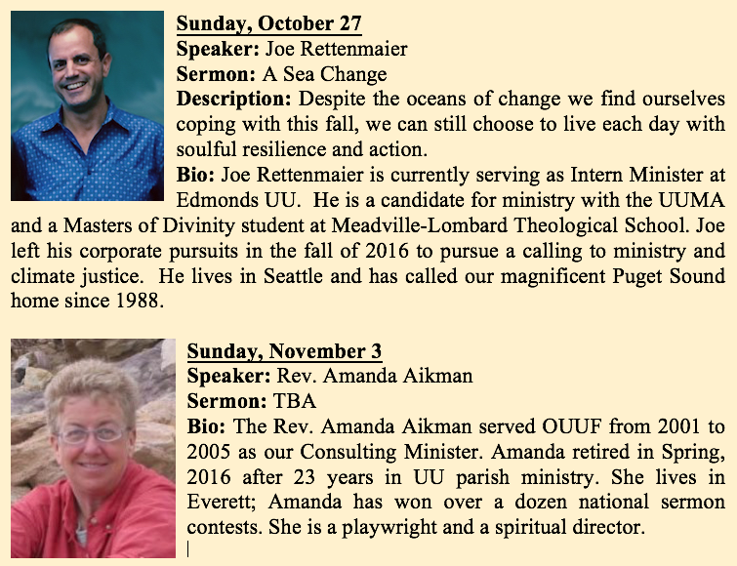

Thursday, October 24
Reflections Women’s Group, newcomers welcome (scent-free)
Contact: Seri Mylchreest, Serena@mylchreest.com

Sunday, October 27
Please join us for coffee and snacks after the service.

Choir Practice, 9:30am
Contact: Joel Yelland at joelyelland@gmail.com

Social Justice Committee, 12:00 pm Contact:
Ren Garypie RenGarypie@yahoo.com 269-719-5215

Monday, October 28
Dance Exercise for Parkinson’s Disease, 10:15am
Contact: Marsha Melnick, (360) 683 - 5712

Tuesday, October 29
Choir Practice, 3:00pm
Contact: Joel Yelland at joelyelland@gmail.com

Wednesday, October 30
Dance Exercise for Parkinson’s Disease, 10:15am
Contact: Marsha Melnick, (360) 683 - 5712

All Things Considered, Women's Evening Group, 7: 00pm, Member's Home
Contact: Jean Stratton (360) 452-6719, jeanmstratton@gmail.com

Men's Evening Group, 7:00pm, Member's Home
Contact: George Stratton (360) 452-6719

Sunday, November 3
Drop – in Support Group for Being Human, hosted by Rev. Amanda Aikman, 12noon

1033 N. Barr Road
P O Box 576
Carlsborg, WA 98324

360-417-2665
info@olympicuuf.com

Calendar
October 24 – November 3
NovOc 21OctoberOct
Oct 4 - 14
Upcoming Sunday Service
October 24, 2019

OUUF Weekly Update
An Inclusive Community
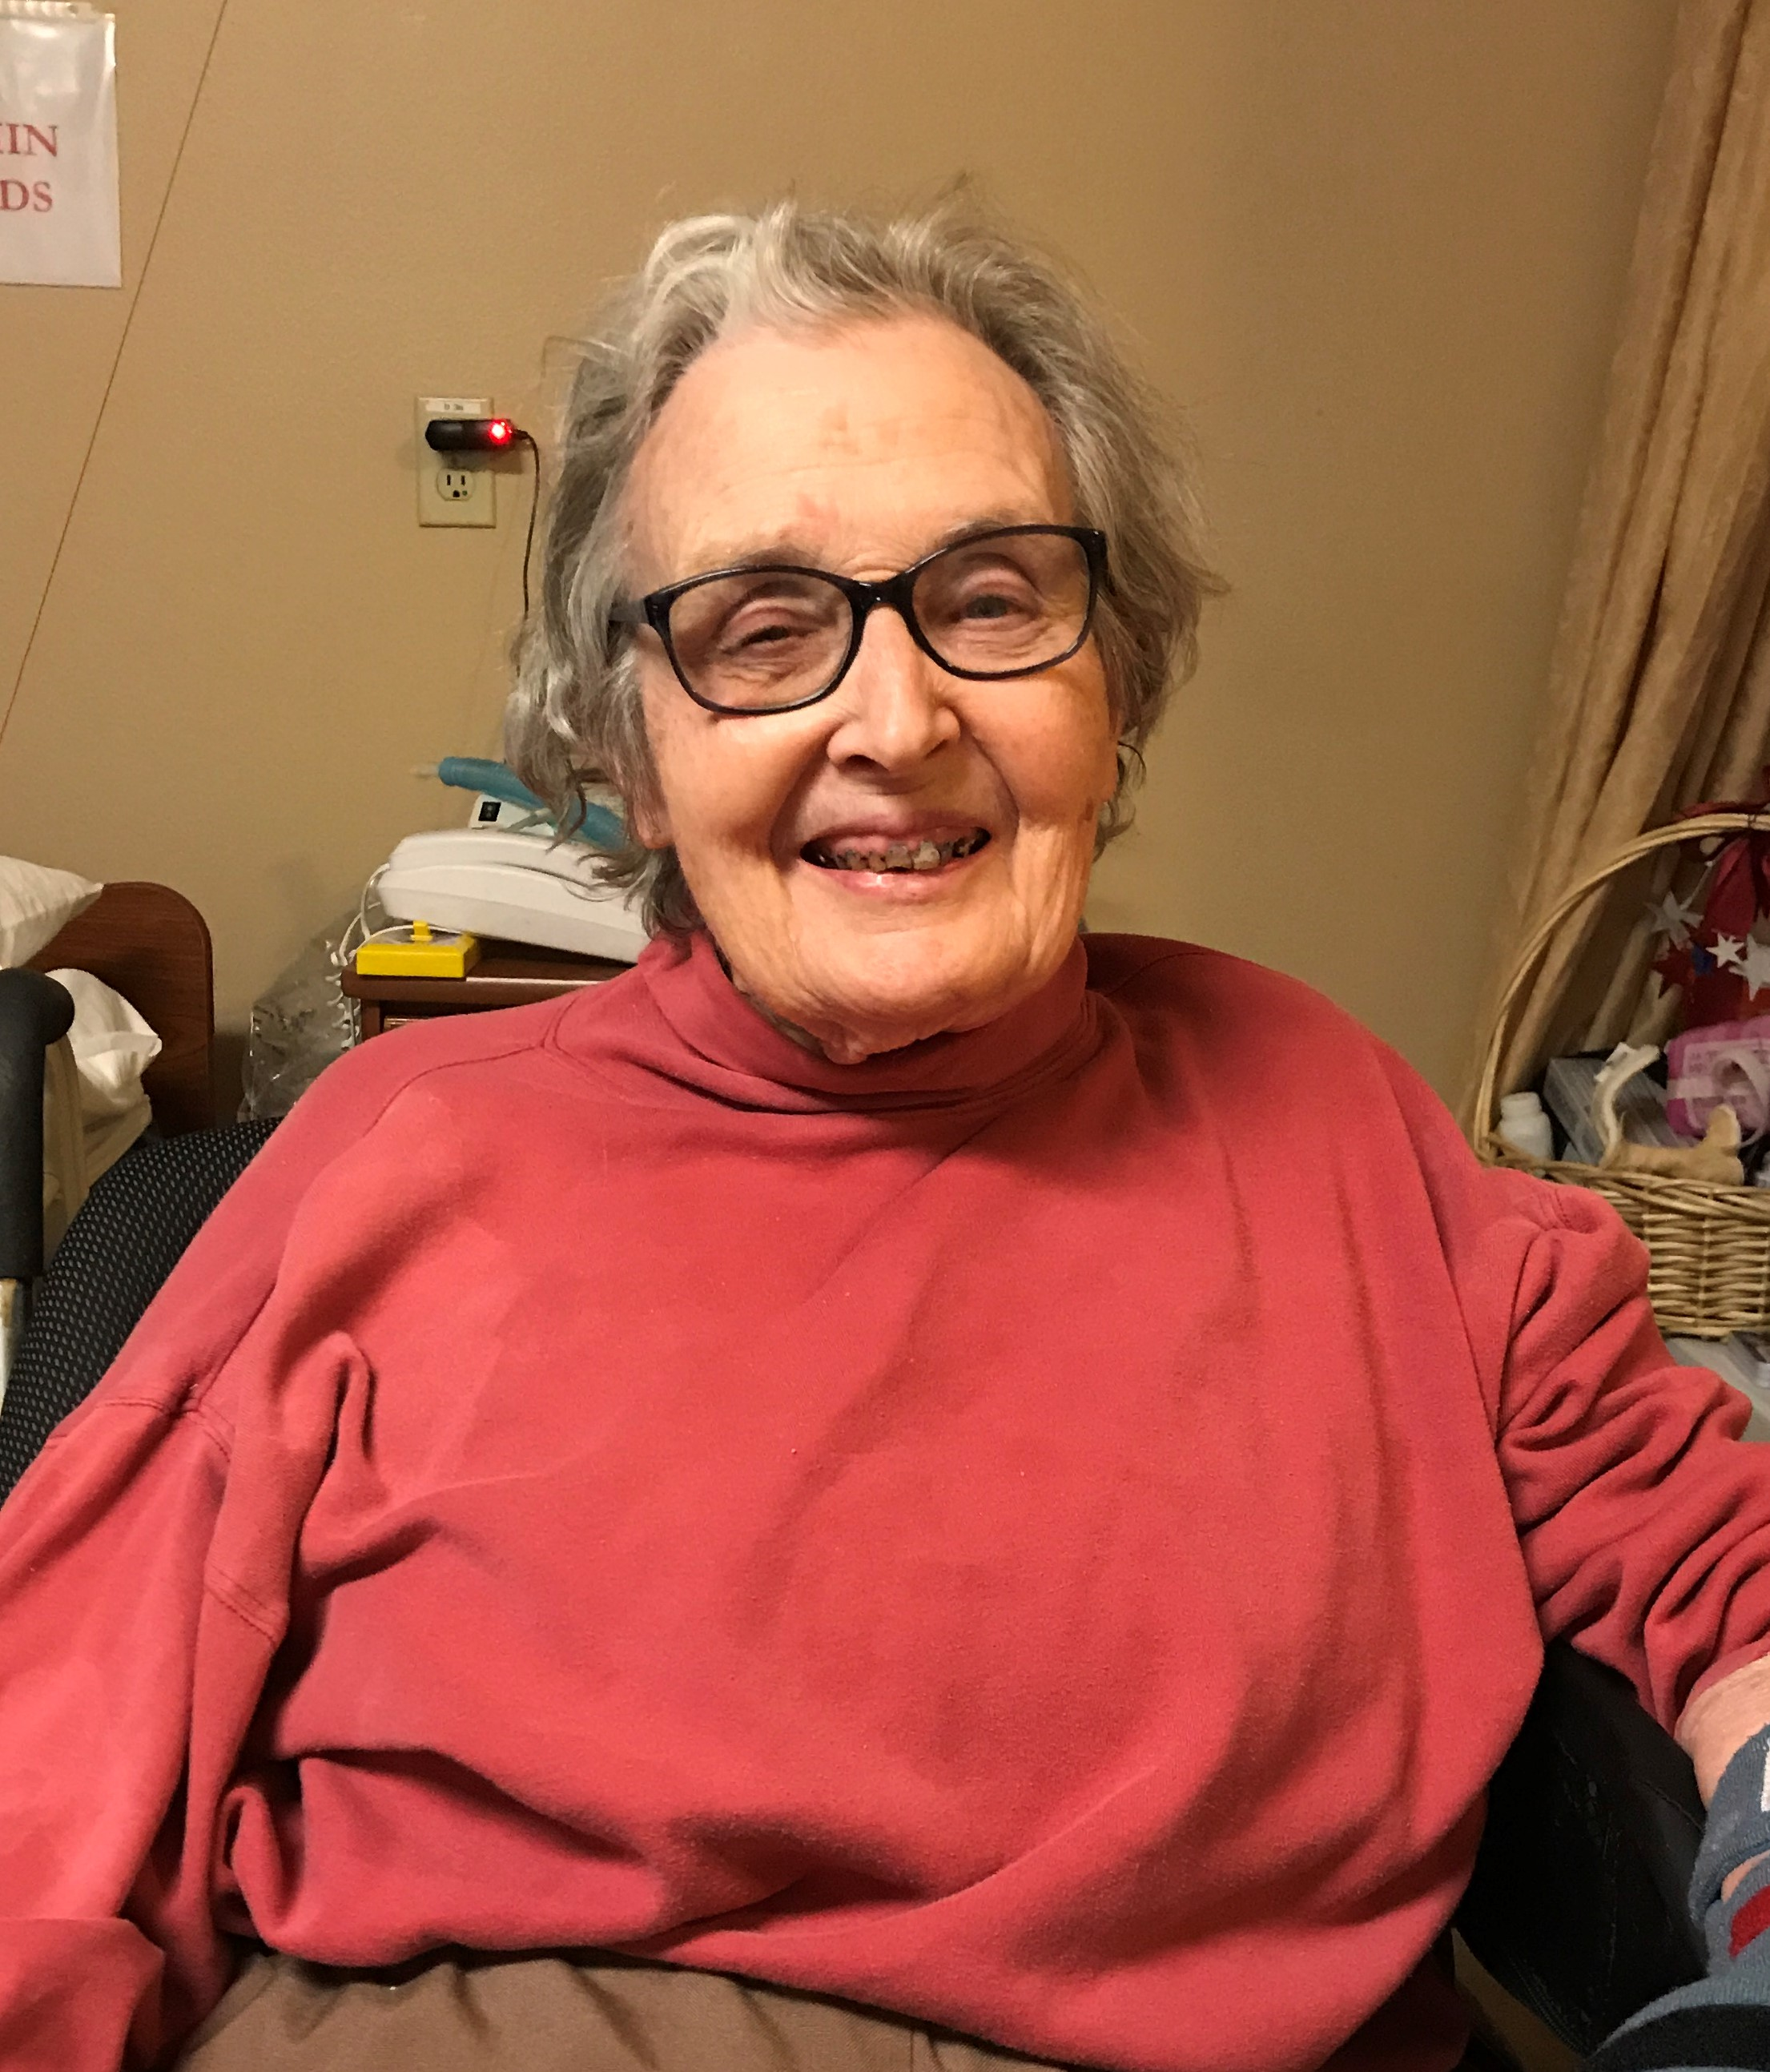
ANNOUNCEMENTS
OUUF BOARD OF TRUSTEES

President:
Dianne Whitaker
President@OlympicUUF.com
Vice President:
Elaine Webber
Secretary:
Dave Large
Treasurer:
Kitty Hawks
Treasurer@OlympicUUF.com

Trustees-at-Large:
Ren Garypie
Pat MacRobbie
Don Hatler
Greg Sensiba

OUUF STAFF

Elinor Tennyson
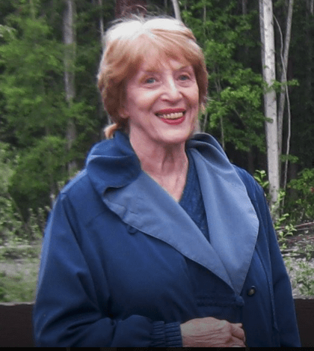
Administrative Coordinator
Admin@OlympicUUF.com

Pattie Miles
Social Media Editor
socialmedia@OlympicUUF.com

Children's Religious Education Staff
Childrensdre@OlympicUUF.com

Julia Buggy
Childrensdre@OlympicUUF.com

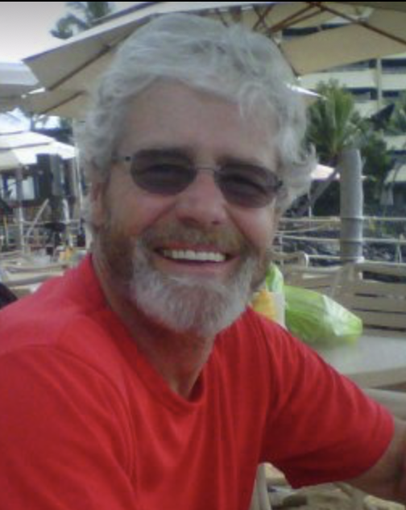
Jack Webber
Webmaster
webmaster@OlympicUUF.com

Pastoral Care Lead: George Will
pastoralcare@olympicuuf.com

Eleanor Nauman, who had been a long-term member of the OUUF, transitioned to ethereal existence this past Monday, Oct 14th in the early morning whilst at the hospital in Port Angeles. She had been dealing with some health issues for a few days. She will be returning to her childhood and family homeland in Chicago and interned on the family plot. May she rest in joy and peace.

PLEDGE DRIVE. Our 2020 annual pledge drive has started. If you have questions about your 2019 pledge (how much you pledged, how much you have paid) please contact Seri Mylchreest at serena@mylchreest.com.
Returning your form as soon as possible makes it easier for your board to budget for 2020.
The link below is the 2020 Congregational Giving form.
https://olympicuuf.com/wp-content/uploads/2019/10/Pledge-2020-Form-FINAL-2.pdf

Dana Casey, raven225@olypen.com. needs a working computer. The ports on the side of her laptop are no longer working, and no one around here replaces Apple hardware. If you have a working computer that you do not use, Dana would like to have it.

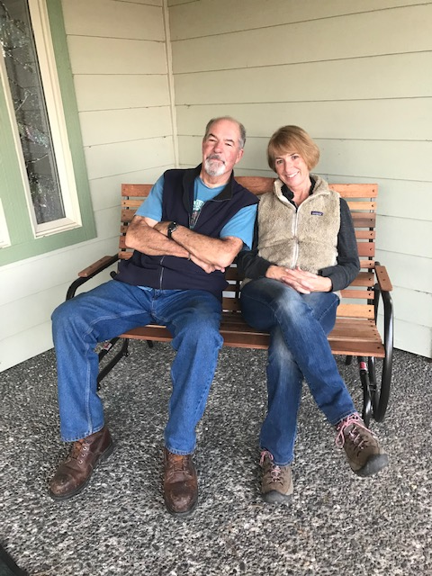

Correction: GLIDER BENCH. Thanks to Penny Burdick for donating the new glider bench. Thanks to Don Hatler for putting it together. Rose Prestipino, chair, landscape team. Photo: The Duffys

SEQUIM COMMUNITY WARMING CENTER – Fundraiser – Cool Talent for Warm Nights, Friday, Oct. 25th, 6-9pm at Trinity United Methodist Church, 100 S. Blake Ave., Sequim. At the door donation: $10 for individuals or $25 per family.
Also, seeking volunteer monitors for when the warming center is open (when it is below 36 degrees), 5 hours shifts between 9pm to 7 am from October to March. Call Jean at 505-264-0278 for details about the fundraiser or volunteering a shift(s) at the center.
See Ren Garypie for details.

The monthly meeting of the Task Force on Social Action is scheduled this Sunday, Oct. 27th after coffee. Contact Ren Garypie at RenGarypie@yahoo.com 269-719-5215

October 31: Herding Cats Halloween! 11 am / lunch of guts and gore. Sequim Bay State Park. Too frightening!
Kitty (alettehawks@yahoo.com).

Contemplative Service: Advance Notice. The last Contemplative Service of the year will be held on Tuesday, Nov. 5th at 6:00 pm. Contact: Diane Hill - Dwyer, djzhill@q.com

It's time for the November/December cycle of potlucks. We're starting the signups a week early this time in case you want to schedule your potluck before the holiday season gets started. If you're already on the potluck list, you will be getting your invitation soon.

7@7 potlucks are informal meals that provide a wonderful opportunity for OUUF members and friends to get to know each other. They don't have to include exactly 7 people at 7 o'clock-- some are held at lunch or brunch time. You may sign up to be a host or not.

You will be sent an invitation once every 2 months. If you are busy you can opt-out and wait for the next cycle. If you opt-in, you'll get an email in about a week with the names of members in your dinner group. The members change each cycle so that you can get to know more people. To join us or for more information contact Serena: serena@mylchreest.com or 360-775-6606.

To Combat Addiction -
We Must ORGANIZE
A Training Event – RIGHT HERE!
Saturday, November 9 (9 – 5)

Olympic Unitarian Universalist Fellowship
1033 N. Barr Rd.
Port Angeles, WA 98362
REGISTER BY NOVEMBER 2 HERE –
https://www.surveymonkey.com/r/PMQ698S

SUBMITTED BY
Sandy Goodwick, sgoodwick@aol.com

ONGOING GROUPS

Reading for the fun of it!
Short Story Book Group
First & Third Tuesdays at 1:00pm
To learn more contact:
Kitty Hawks
206-755-2832 or
alettehawks@yahoo.com

Tuesday Brunch
Second and Fourth Tuesdays
11 am at the Mariner Restaurant in the JCPenney mall in Sequim
For more information contact:
Rose Prestipino, roseprestipino@gmail.com

OUUF Men’s Group
Wednesdays, 7-9 pm
At members’ homes.
For More information contact:
George Stratton
(360) 452-6719

OUUF Women’s Groups
All Things Considered
Evening Group
Wednesdays, 7-9 PM. At members’ homes
For More information contact:
Jean Stratton
360-452-6719 or
jeanmstratton@gmail.com

Reflections
Second and fourth Thursday 1-3 PM at the Fellowship Hall
For More information contact:
Serena Mylchreest
serena@mylchreest.com

Choir
OUUF Sundays at 9:30 am and Tuesdays at 3:00 pm.
Newcomers welcome!
For More information contact:
Choir Director
Joel Yelland
509-322-5328 or
JoelYelland@gmail.com

For details on how to join or start an OUUF Affinity Group:
OUUF Affinity Groups

