++++++++++++++++++++++++++++++++++++++++++++++++++++++

MAY 3, 2020 SUNDAY SERVICE

Our OUUF Zoom mini-service on Sunday the 19th was well received. Margo presented a wonderful mini-message that left us thinking about something other than Covid-19. Thanks to Joan Cotta, Sandy Goodwick, Cynthia Green, Bob Nuffer and Joel Yelland for making this happen.

Your board of trustees met Sunday afternoon. We still don't have a reopening date for in-person services and are waiting guidelines from the state. We will let you know as soon as we know. Dianne Whitaker

We will send an email with the order of service, and the Zoom dial in information at the end of the week

Stay safe and enjoy the Great Pause

+++++++++++++++++++++++++++++++++++++++++++++++++++++++

FELLOWSHIP FISCAL HEALTH:

Please mail your donation/pledge to the address below

OUUF
P O Box 576
Carlsborg, WA 98324

If you have any questions please contact Don Hatler at donaldhatler1936@gmail.com or Serena Mylchreest at serena@mylchreest.com
+++++++++++++++++++++++++++++++++++++++++++++++++++++++++++

OUUF BOARD OF TRUSTEES

President:
Dianne Whitaker
Vice President:
Joan Cotta
Finance Director
Don Hatler
Trustees-at-Large
Dave Large
Ren Garypie
Sarah Whelchel
Sandy Goodwick
OUUF STAFF

Elinor Tennyson
Administrative Coordinator
Admin@Olympicuuf.com

Children's Religious Education Staff
Julia Buggy
Juliafbuggy@gmail.com
Harmony Rutter
Izzy Flowers

Care Team
acting lead for George Will:
Jean Stratton
jeanmstratton@gmail.com

Jack Webber
Webmaster
webmaster@OlympicUUF.com

April 26-May 3, 2020

1033 N. Barr Road
P O Box 576
Carlsborg, WA 98324
360-417-2665

OUUF Weekly Update
An Inclusive Community

ANNOUNCEMENTS
We reserve the right to edit your submission for length and grammar
+++++++++++++++++++++++++++++++++++++++++++++++++++++++++++++++++++++++++
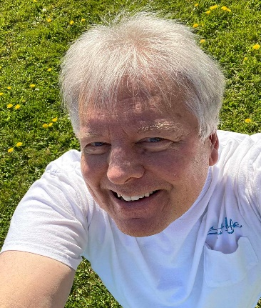

Photos used in this newsletter were taken by Phil Zenner
Phil is part of the Landscape Team and had stopped by the Fellowship to hand-water our lovely plants and was moved to capture some of the beauty OUUF grounds have to offer.
Thank you, Phil

+++++++++++++++++++++++++++++++++++++++++++++++++++++++++++++++++++++++++
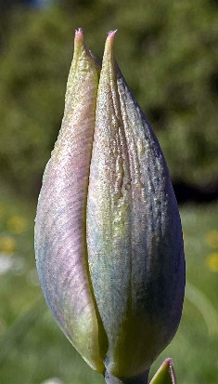
ZOOM MEETINGS:
You will receive separate emails for different Zoom meetings, like Children’s (and adult’s RE) the Men’s Wednesday Group and weekly Community Sharing. A HUGE thank you goes to Sandy Goodwick, George Stratton and Joan Cotta for working to make these happen. This is an excellent way to connect with our community and well worth the patience it may take to master joining and participating. All three of our great Zoom leaders are available if you have any questions. Sandy Goodwick at (818) 489-8626, or George Stratton at (360)-452-6719, or Joan Cotta at (408) 206-0666,

+++++++++++++++++++++++++++++++++++++++++++++++++++++++++++++++++++++++++
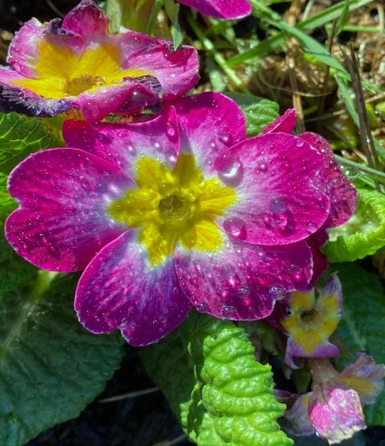
A MINUTE OF CONNECTION:
No matter your personal situation, these are trying times. Many of us rely on our OUUF community to drawn strength and find peace. We miss our person to person contact whether it has been weekly or several times each week. How can we keep connected? Azella called me the other day and suggested we pick a time each week when we take a minute to take a deep breath, be perfectly quiet, meditate or pray, knowing we are connecting with our OUUF community Sunday, the 3rd of May at 1:00 PM please join us in this minute of connection.
Dianne Whitaker
+++++++++++++++++++++++++++++++++++++++++++++++++++++++++++++++++++++++++
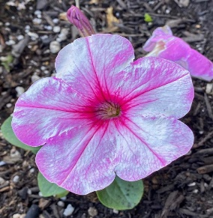
SHARE YOUR PICTURES:
Would you like to share pictures and/or videos of your flowers, your view while “social distancing”, your pets or ??? Find a picture (or several) that have meaning for you... maybe a video you took on your cell phone... and if you send them to me (either email - sgoodwick@aol.com, or cell 818-489-8626) I will turn it into an OUUF home movie... something for our website. (An iMovie... nothing incredibly hard... kids learn how to make them in elementary school) - Sandy Goodwick
++++++++++++++++++++++++++++++++++++++++++++++++++++++++++++++++++++++++

+++++++++++++++++++++++++++++++++++++++++++++++++++++++++++++++++++++++++
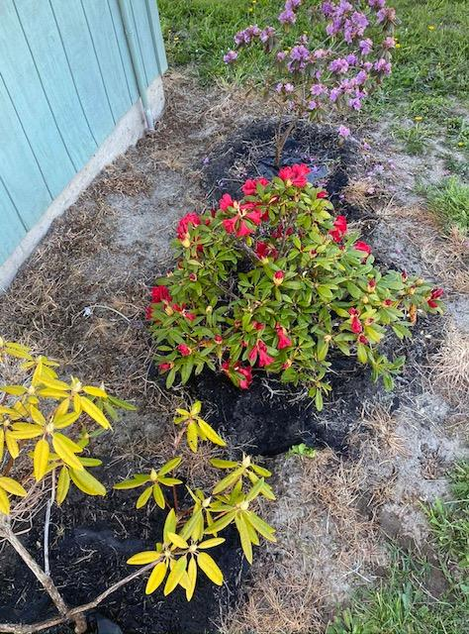
FACE MASKS
If you need a cloth face mask contact Seri Mylchreest serena@mylchreest.com 360-775-6606

NEED T-SHIRTS:
If anyone has old T-shirts they are not wearing I could use some to make ties for face masks. There is a shortage of the narrow elastic, and some people find the masks with fabric ties more comfortable. Please contact serena@mylchreest.com.

+++++++++++++++++++++++++++++++++++++++++++++++++++++++++++++++++++++++++
OUUF Care Team
Just an update to let you know we do care about our members and friends during this time of distance. If you are home and have a need or a medical condition, please remember we can call you or send you cards or drop off groceries if need be. We care about all of you during this difficult time of no church live services and gatherings.
Our team of Ren Garypie,, Cynthia Green, George Stratton, Sandy Goodwick, Dianne Whitaker and myself as acting chair are here to help you. Please know you can contact me, Jean Stratton at 360 452-6719, or by email: jeanmstratton@gmail.com
You are part of our loving community.
++++++++++++++++++++++++++++++++++++++++++++++++++++++++++++++++++++++++++++++++
GOOD NEWS:
From Dana Casey
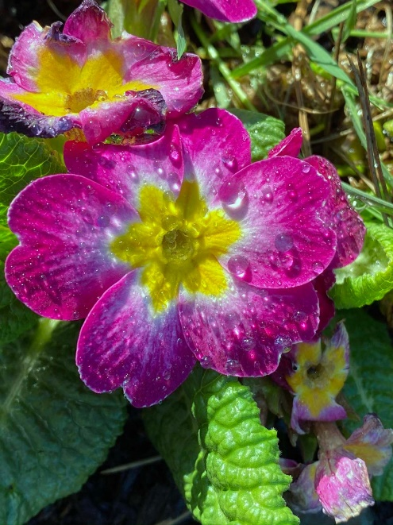
Social Security finally came through with some of Jim’s pension for me. They also sent me a lump sum for the 7 months they had not paid me. With deep gratitude for all the help OUUF gave me last fall and winter, I am making a donation of $1,000. I cannot thank everyone personally since much of the monetary help came anonymously. I hope my contribution to OUUF will serve as a thank you to everyone. I would not have made it through those terrible first months without all your support and help.

++++++++++++++++++++++++++++++++++++++++++++++++++++++++++++++++++++++++++++++++

++++++++++++++++++++++++++++++++++++++++++++++++++++++++++++++++++++++++++++++++
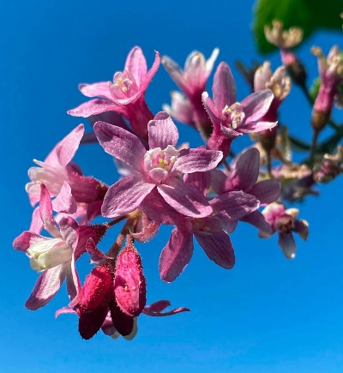
BROADCASTS:
From: Florence Burierka
Here is a spreadsheet link that was in the Seattle Times. It has broadcasts from the Met, National Theatre of London, etc . – all over the world. Michael downloaded sites to our laptop, and we can plug the laptop into our TV and watch them on the TV. Great opportunities to see things we never have seen.
https://docs.google.com/spreadsheets/d/1JC9gQn8-e_hL6vZGPBENdt_a3QEkcZVmbi3rv4_xNzE/htmlview?usp=sharing

+++++++++++++++++++++++++++++++++++++++++++++++++++++++++++++++++++++++++
Joel Yelland sang several songs as part of the April 19th Sunday service.
The lyrics below were sung to the tune "When the Summer Sun Is Shining", #66 in the gray hymnal Wikipedia says it's one of the earliest American hymn tunes, written 1829.
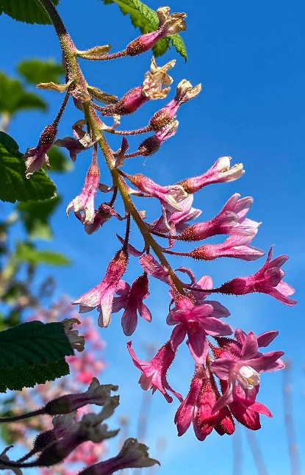
Kindred, now we meet to worship,
Reaching out through screen and phone.
Though we dwell in isolation,
We don’t have to be alone.
Worshipping beyond our building,
Our connection’s no less real.
Though we cannot meet in person,
Covenant unites us still.
Siblings, share a song of gladness,
Lifting spirits, spreading cheer.
So that in these days of sadness,
We won’t be consumed by fear.
In this time of mass confusion,
Sickness, loss, and overwhelm,
Let’s encourage one another;
Hands not joined, but hearts are held.
Friends, be gentle with each other,
There’s so much we’re going through.
May this be a time for healing,
Holding space for grieving too.
Bodies, minds, and hearts are weary,
Anguish fills the aching soul,
But we know with perseverance,
Broken hearts can be made whole.

--Words by Thommy Snell
+++++++++++++++++++++++++++++++++++++++++++++++++++++++++++++++++

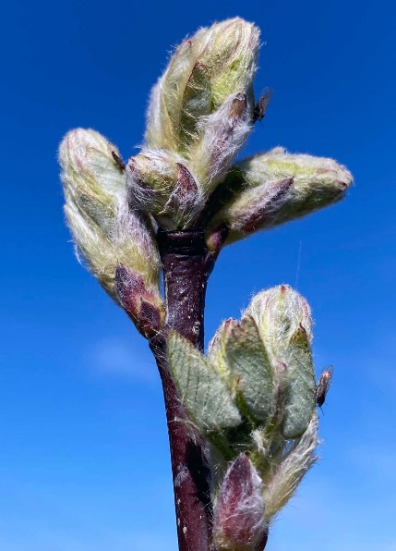
+++++++++++++++++++++++++++++++++++++++++++++++++++++++++++++++++++++++++ HELPING PEOPLE IN NEED BECAUSE OF COVID-19
Two good choices to send money to people in need in our area who are impacted by the Coronavirus are:
(1) UNITED WAY OF CLALLAM COUNTY.
Write your check to United Way of Clallam County. Designate on your check Clallam COVID-19 FUND. Mail your check to United Way of Clallam County, P.O. Box 937, Port Angeles, WA 98362.
(2) PENINSULA HOME FUND.
This fund is sponsored by the Peninsula Daily News and managed by OLYCAP. Write your check to “Peninsula Home Fund.” Designate on check COVID-19 Relief Fund. Mail check to Peninsula Daily News Home Fund,
P.O. Box 1330, Port Angeles, WA 98362.
…
Both organizations will distribute money to people in need. The former fund stays in Clallam County, the latter fund in Clallam and Jefferson Counties. – Ren Garypie
++++++++++++++++++++++++++++++++++++++++++++++++++++++++++++++++++++++++++++++++++++++++SPRING IS HERE!
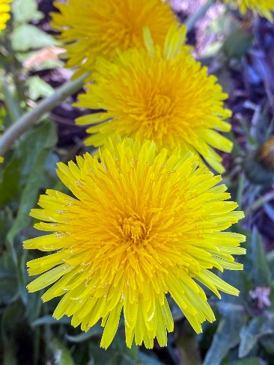
OUR FELLOWSHIP IS BEGINNING TO LOOK ALIVE WITH COLOR!

We have lovely fields of dandelions – you are invited to

harvest them for making tea, wine, greens, etc.

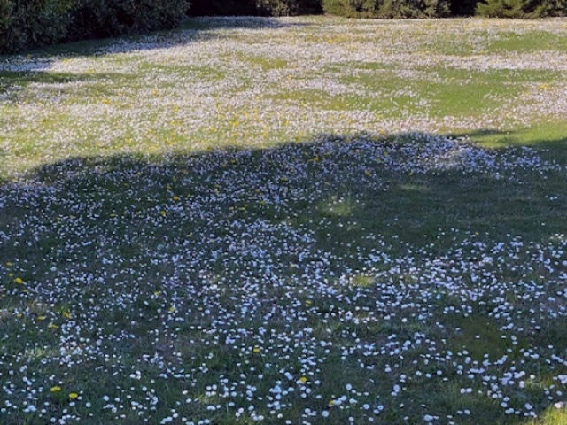

A soft field of flowering “weeds”

soon to be mowed down!

